**Add Two Numbers**

You are given two non-empty linked lists representing two non-negative integers. The digits are stored in reverse order, and each of their nodes contains a single digit. Add the two numbers and return the sum as a linked list.

You may assume the two numbers do not contain any leading zero, except the number 0 itself.

**Example 1**

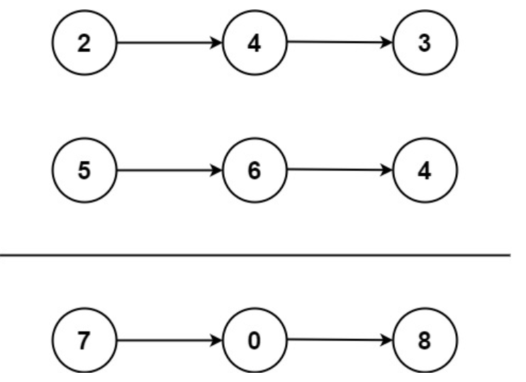

* **Input: l1 = [2,4,3], l2 = [5,6,4]**
* **Output: [7,0,8]**
* **Explanation: 342 + 465 = 807.**

**Example 2:**

* **Input: l1 = [0], l2 = [0]**
* **Output: [0]**

**Example 3:**

* **Input: l1 = [9,9,9,9,9,9,9], l2 = [9,9,9,9]**
* **Output: [8,9,9,9,0,0,0,1]**

**Constraints:**

* **The number of nodes in each linked list is in the range [1, 100]**
* **0 <= Node.val <= 9**
* **It is guaranteed that the list represents a number that does not have leading zeros.**